|  |
| --- |
| [Company name] |
| Ict project |
| WEB BASED RENTAL HOUSE MANAGEMENT SYSTEM |

|  |
| --- |
| Mungai samuel kuria sct 121-0550/2021  [Date] |

WEB BASED RENTAL HOUSE MANAGEMENT SYSTEM

**ABSTRACT**

We are stuck with technology when what we really want is just stuff that works. With the current development in technological field, there is an urgent need to embrace and appreciate the power of technology. Housing sector remains vigilant to face the challenges of change by employing a new strategy that facilitates easy management of rental houses. Hence there is need to develop a rental house management system that can simplify work for the rental managers so that all their work can be efficient and effective. To get information about how rental houses are currently being managed, I prepared questionnaires and submitted them to a number of rental house managers and from the information I gathered I realized all work was done manually with a lot of paper work involved. Papers can easily get damaged or get lost leading to loss of data. It is also expensive to keep on buying files to store your records. A lot of files make a place look untidy and also consume a lot of space. Getting a certain file to check data from many files becomes a difficult task. Considering those facts, I decided to develop a rental house management system that can solve all the problems experienced with the current manual system. The system will be developed using(PHP (Hypertext pre-processor) programming language using the XAMPP as the testbed.

**INTRODUCTION**

Rental house management has become important factor in modern society hence the need to have a rental house management system. This chapter will provide a brief understanding about background of study, definition of the project problem statement, its objectives, scopes, project justification, risks, project deliverables and project budget and schedule.

**BACKGROUND OF THE STUDY**

Housing has a great importance to quality of life with considerable economic, social, cultural and personal significance. Though a country’s prosperity is usually measured in economic terms, increasing wealth is of diminished value unless all can share its benefits and if the growing wealth is not used to redress growing social deficiencies, one of which is housing. Housing plays a huge role in revitalizing economic growth in any country, with shelter being among key indicators of development. Housing as a basic human right demands that urban dwellers should have access to a decent housing, defined as one that provides a foundation for rather than being a barrier to good physical and mental health, personal development and fulfilment of life objectives. The focus of this research project is basically managing housing for low income, medium and high incomes households or what is commonly known as affordable housing. Affordable is a term used to describe individuals‟ capability to pay for certain products or services because their income is enough to do so. Although the term „affordable housing‟ is often applied to rental housing that is within the financial means of those in the lower income ranges of a geographical area, the concept is applicable to both middle and high income individuals. Most families choose to rent houses based on their income and family situations; unfortunately, there may not be enough good quality rental housing for these families. Housing is a major problem in Kenya especially in Nairobi. Millions of people are living in sprawling slams and also in other informal settlement around Nairobi. This explains why many people have shifted their focus to developing rental houses in Kenya and other parts of the country. The demand for rental houses is extremely high and more rental houses need to be put in place. Developing rental houses comes with many advantages especially to the Landlords who are able to increase their profits through rent paid by the tenants. Increased number of tenants and Landlords makes management difficult especially for the landlords who are losing huge sum of money through tenants who evade rent. The above statement gives a clear declaration as to why rental house management system need to be developed.

**STATEMENT OF THE PROBLEM**

Over the years landlords/property managers have had a problem in maintaining and managing their customers and their own records. Management has become difficult because of issues that include:

1. Lack of computerized system

Currently most landlords/property managers use the manual system in recording and maintaining their property and customers data

1. There is no database to store information

` Potential of data loss or damage is very high because data is stored on tangible files.

Lack of these crucial requirements makes management of the tenants and houses very difficult as some tenants may end up not paying rent.

**Proposed solution**

* proposed system is fully computerized one. It does absolutely nothing on paper .As all the entire working is done with the aid of computers, this will result in faster  processing and improved performance. This information can be quickly by the click of a button when compared to earlier retrieval from files and registers. As all the details are stored in the computers hard drive the physical storage space requirement can be reduced to a great extent. processing of information manipulation was difficult with manual system, but as we are doing all the processing with the aid of computers it can be done very easily and accurately. creating reports timely needs a quick search in the huge file cabinets, but with the proposed system reports can be generated in the winks of an eye lid. The proposed system overcomes all the limitations of the existing system. It gives a clear view of the wok to be done. It maintains the data safe and secure. system can generate report regarding daily, and monthly earnings of shows. there will be no chance of missing any documents as there is no paper work.

**AIM AND OBJECTIVES**

The aim of this project work is to design and develop a functional Apartment rental management and service maintenance electronic platform.

The following are the project objectives:

● To develop a rental house management system that allows the user to view customers‟ data as well as houses record

● To develop a system that allows the users to add, edit, search and delete data from the database

● To study and analyse the requirement specifications of the rental house management system

**Significance of the project.**

There always exists a need to check for information organization in today’s world especially when it comes to financial as well as keep record of an already client information for future reference. Therefore, the rental management system is imperative as its acts as an auxiliary to effectively manage real estate resources and to provide optimal service for clients.

**BENEFITS OF THE PROPOSED SOLUTION**

### Accounting and Budgeting

Easy rental management system is fully integrated with financial module. It implements efficient recording of data.

### Rent Payment Processing

The software eases the task of rent payment and its management. Collection of rent from tenants in a regular and efficient manner is one most important feature of the rental management software. Most of them provide their users with online payments methods like mpesa.

### Tenant Management

With the help of the software, one can easily create a tenant database.

**Chapter 2**

**Literature Review**

Literature review is a text written by someone to consider the critical points of current knowledge including substantive findings as well as theoretical and methodological contributions to a particular topic.

**WEB BASED RENTAL HOUSE MANAGEMENT SYSTEM**

Rental house management system is a computer based system which is used to monitor the various activities of a regular residential metropolitan society. The concept of Rental house management system has arisen from the fact that various large societies need monitoring and maintenance for their various day to day activities.

In a normal residential society, the day to day chores include maintenance of the society, plumbing, parking allocations, waste management, security facilities, tracking dues, inventory management etc. these activities individually are very tedious and long processes. They require the co-ordination between the respective management societies coupled with the vendors which provide these services so that the appropriate convenience can be provided. Apartment management is the operation, control, and oversight of real estate as used in its broadest terms.

**EXISTING SYSTEM**

Currently the most property managers manage property and tenants details on papers. Once customers find a vacant house, they can call or email manager of the houses indicating the size of the house they would like rented to them. The property manager can email them back giving them all the details about the house they are requesting. The details include; Rent per month Deposit paid Terms and conditions to follow acceptance

**PROBLEM OF EXISTING SYSTEM**

With the current system recording the details of various activities of user is completely manual and entails a lot of paper work. Each house has a file that contains the house: number, size, rent per month, expected deposit, occupant and status. Rent payment table contains tenants: first name, last name, Phone number, date of payment, amount and balance if any. The existing system only provides text based interface which is not as user friendly as Graphical user interface. Since the system is implemented manually, the response is very slow. The transactions are not secure as papers may get lost or damaged. Hence, there is need of reformation of the system with more advantages and flexibility. The system eliminates most of the limitations of the existing system.

REQUIREMENTS ANALYSIS

Requirement analysis involves defining customer needs and objectives in the context of planned customer use, environments and identified system characteristics to determine requirements for system functions.

User Requirements

It entailed user involvement and statements of facts and assumptions that define the expectations of the system in terms of mission objectives, environment, constraints and measures of effectiveness and suitability. Basically the users:

1. A system that improves on the efficiency of information storage and retrieval.
2. A system that is easy to learn and use
3. A system that is fast in processing transactions
4. A system that is flexible, safe and convenient

Functional Requirements

This is a necessary task, action or activity that was accomplished. The proposed system is able to:

1. Allow administrator to add a houses, tenant and defaulters details
2. Allow the administrator to delete houses, tenants and defaulters details
3. Allow the administrator to search data in the database
4. Allow the administrator to edit data in the database
5. Allow reporting by tenants
6. Allow payment via mpesa
7. Able to generate notifications alerts

**Hardware Requirement**

**Processor:** Intel(R) Core i5 or higher

**Installed Memory:** 4.00GB or higher

**Operating System:** 32/64-Bit operating system, x86/x64-based processor

Budget estimation

|  |  |  |  |
| --- | --- | --- | --- |
| Item description | quantity | Unit cost | Total cost |
| Internet connection | 1 | 4500 | 4500 |
| laptop | 1 | 30,000 | 30,000 |
|  |  |  |  |
|  |  |  |  |
|  |  |  |  |

Feasibility Report

Feasibility study is the high level capsule version of the entire requirement analysis process. The objective of feasibility study is to determine whether the proposed system can be developed with available resources.

There are three steps to be followed for determining the feasibility study of proposed system.

1. Technical Feasibility
2. Operational Feasibility
3. Economic Feasibility

Technical Feasibility: It is concerned with hardware and software feasibility. In this study, one has to test whether the proposed system can be developed using existing technology or not. If new technology is required, what is the likelihood that it can be developed according to client requirements.

Operational Feasibility: Operational feasibility determines whether the proposed system satisfied the user objectives and can be fitted in to current system operation.

Economic Feasibility: This includes an evaluation of all incremental costs and benefits expected if proposed system is implemented. costs-benefit analysis which is to be performed during economic feasibility delineates costs for project development and weighs them against benefits of system.

**SYSTEM DEVELOPMENT AND METHODOLOGY**

System development methodology is a technique that is used to show how the proposed system will be developed. In this case, the methodology used will be system development life cyle.

**System Development Life Cycle**

A software development methodology is a framework that is used to structure, plan, and control the process of developing an information system, this includes the pre-definition of specific deliverables and artefact’s that are created and completed by a project team to develop or maintain an application. A wide variety of such frameworks have evolved over the years, each with its own recognized strengths and weakness. One software development methodology framework is not necessarily suitable for use by all projects. Each of the available methodology frameworks are best suited to specific kinds of projects, based on various technical, organizational, project and team considerations. These software development frameworks are often bound to some kind of organization, which further develops, supports the use, and promotes the methodology framework.

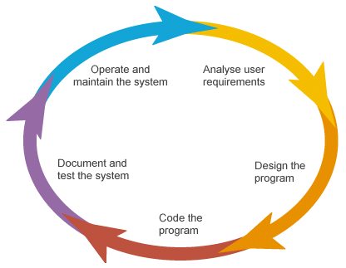

**Design**

This stage will include the overall design of the system, that is, the User Interface and the database design. This stage will help in identify faults from the previous phase (missing information) and its output, which is the design specification, will help in the next stage of implementation

**Implementation**

This is the stage that coding is done as per the design specification(s). The user interface will be implemented with HTML ,PHP 7 scripting language to establish communication between the interface and the database. The database design will be implemented using SQL with MySQL as the Database Management System. All these will result to the product components built according to a pre-defined coding standard and debugged, tested and integrated to satisfy the architecture requirement of the system.

**Testing**

This is the stage that will test the system to ensure that they are fault free and are made per the user requirements. This will involve both alpha testing that will involve testing at the development site, unit testing of individual code module and system testing of the integrated product. The bugs found will be corrected before moving to the next stage. Preparation, reviewing and publishing of the documentation will be done at this stage.

**Deployment**

This stage is done once the product has been tested and certified as fit for use. The system is prepared for use large scale.

**Maintenance**

This stage occurs after installation. It involves modifications on the system to improve performance per the user requirements or change of technology. Sometimes it is required due to the appearance of bugs that were not initially encountered. These modifications are recorded for documentation and system update.

TIME FRAME

|  |  |  |  |  |  |  |  |  |  |  |  |  |  |  |  |  |  |  |  |  |  |  |  |  |
| --- | --- | --- | --- | --- | --- | --- | --- | --- | --- | --- | --- | --- | --- | --- | --- | --- | --- | --- | --- | --- | --- | --- | --- | --- |
| |  |  |  | | --- | --- | --- | | City or Town | Estimated Starting time | Estimated Stopping time | | Proposal writing | 24th/1/2023 | 14th/2/2023 | | Feasibility study | 17th/2/2023 | 18th/2/2023 | | Requirement analysis | 19th/2/2023 | 21st/2/2023 | | design | 22nd/2/2023 | 8th/3/2023 | | implementation | 9th/3/2023 | 15th/3/2023 | | testing | 16th/3/2023 | 27th/3/2023 | | documentation | 28th/3/2023 | 4th/4/2023 | |

**Feasibility study**

Dear respondent; I am samuel kuria a student undertaking a research project on Rental House Management. Your support towards this research will be appreciated and be treated with utmost confidentiality and for only academic purposes.

SECTION A: Background information of the respondents Fill in the questions below by ticking where appropriate

1. Kindly indicate your gender Male Female

2. Which is your age bracket? 18-25years 26-32years 33-55years 56 and above

3. What is your highest academic qualification?

PhD Masters Degree Diploma Certificate

4. What motivated you to venture into rental houses business? ………………………………………………………………………

5. How many rental houses do you have? Indicate Number………………….. 6. Do you have challenges in managing your houses? Yes No 7. If yes, kindly indicate some of the challenges you face i)……………………………………………………………………………………… ii)……………………………………………………………………………………… iii)………………………………………………………………………………………… iv)………………………………………………………………………………………… v)………………………………………………………………………………………… vi………………………………………………………………………………………… vii…………………………………………………………………………………………. viii…………………………………………………………………………………………. ix)…………………………………………………………………………………………… x)……………………………………………………………………………………………

8. Kindly indicate the greatest challenge(s)? i)………………………………………………………………………………………….. ii)…………………………………………………………………………………………… iii)……………………………………………

8. Would you like to have a system that can assist you in management? Yes No

SECTION B: Management System Please indicate your level of agreement with the statements below

|  |  |  |  |  |  |
| --- | --- | --- | --- | --- | --- |
| Statement | Strongly Agree | Agree | Strongly Disagree | Disagree | Not Sure |
| 5 The main objective of developing rental houses is to make money through rent paid by tenants |  |  |  |  |  |
| Rental houses need to be managed by a system |  |  |  |  |  |
| Management will assist to achieve the objective of owning rental houses |  |  |  |  |  |
| The managing system should be easy to understand, flexible and quickly accessible |  |  |  |  |  |
|  |  |  |  |  |  |

**REQUIREMENT ANALYSIS**

This chapter includes functional, non-functional, user, hardware and software requirements for the Rental House Management System. This involves defining customer’s needs and objectives to determine requirements for the system functions.

**CURRENT RENTAL HOUSE MANAGEMENT SYSTEM**.

The current system of managing rental houses include:

* Paper based contracts and forms.
* Spreadsheet and/or paper-based management of the information which include payment, tenant and house information.
* Physical finding for vacant houses.

**USER REQUIREMENTS.**

These are the requirements which outlines user involvement and statements of facts and assumptions that define the expectations of the system in terms of mission objectives, environment, constraints and measures of effectiveness and suitability.

* Digital signing of the contract and renewing of the contract by tenants.
* House owner registering the house and showing relationship between the houses and tenants which include contract and payment.
* House owners messaging the tenants their due dates.
* Creating digital forms that require the tenants to fill the status of the house upon entering and exiting of the house
* Tenants performing online registration, payment and being able to view their arrears.

**INTERFACE DESIGN.**

This system’s interface is based on two templates that were customized to suit the needs of the system. One the design was used for the index page and the other was used for the rest of the pages.

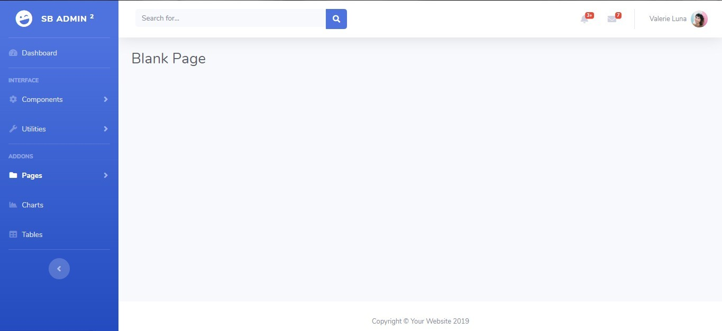

Figure:  The  design  for  Rental  House Management  System  from  SB  ADMIN2

Bootstrap template

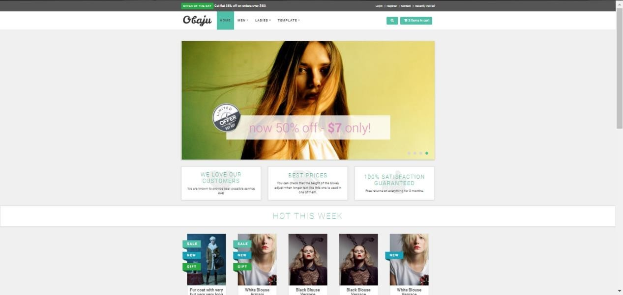

Figure: The index page design for Rental house Management System’s index page

from OBAJU Bootstrap template.

**FUNCTIONAL REQUIREMENTS.**

These are the requirements that define the functions of the system where a function is described as a specification of behaviour between outputs and inputs.

The functional requirements for the proposed system include:

* The system must allow a tenant to register his particulars and that of his contacts.
* The system must allow the tenant to sign a contract, perform online payment and fill a tenant-in form upon logging into the system
* The system must allow the system administrator to add house, fill tenant- out form upon the tenant’s end of contract, send text messages (SMS) via the system and edit and delete various components from the system which include tenants, contracts, house and payment.
* The system must allow the manger to fill the tenant-out form upon the tenant’s end of contract and send text messages (SMS) via the system.
* The system must allow all the users of the system to view contract, tenant, house and payment information from the system.

**NON-FUNCTIONAL REQUIREMENTS.**

These are requirements that describe the quality of the system imposing the constraints on the design and implementation.

The non-functional requirements will include:

* The system will use the PHP sanitization functions and validation to prevent MySQL injections and entering useless data into the database.  
  The passwords will be encrypted using the MD5 algorithm so as to ensure the confidentiality of data in the system. Therefore no one can be able to retrieve the password hence violating confidentiality of another user.
* Each user will access the system according to his role in the system therefore no user can access the interface of another user.
* The system will be compatible to all platforms both Operating Systems and web browsers since it is web-based.

4.6.     HARDWARE REQUIREMENTS.

* Processor of at least 2.0 GHz processor speed.
* Memory of at least 2 GB RAM

4.7.     SOFTWARE REQUIREMENTS.

* Operating System (Windows, Linux and MAC)
* Web browser.
* Text Editor for writing PHP Codes
* Web server which may include: XAMPP,WAMP or LAMPP

**SYSTEM DESIGN**

In this chapter, the system design will be demonstrated. It will focus on showing conceptual and physical design of the databases and the user interaction with the system using the Unified Modelling Language (UML) diagram called Use Case Diagram.

**CONCEPTUAL DATABASE DESIGN.**

Conceptual Design is the first stage of design in which the drawings are the dominant tools and products. The purpose of the conceptual design phase is to build a conceptual model based upon the previously identified requirements, but closer to the final physical model.

In this case the conceptual design model used is the Entity-Relationship (E-R) Diagram. It shows in a nutshell the relationship between the entities and their attributes.

Figure 4 shows two entities user and transaction for Tuma pesa Database

Figure 5 shows eight entities namely, tenant, house, payment, contract, tenant-in, tenant-out, user and contacts for Rental House Management System Database.

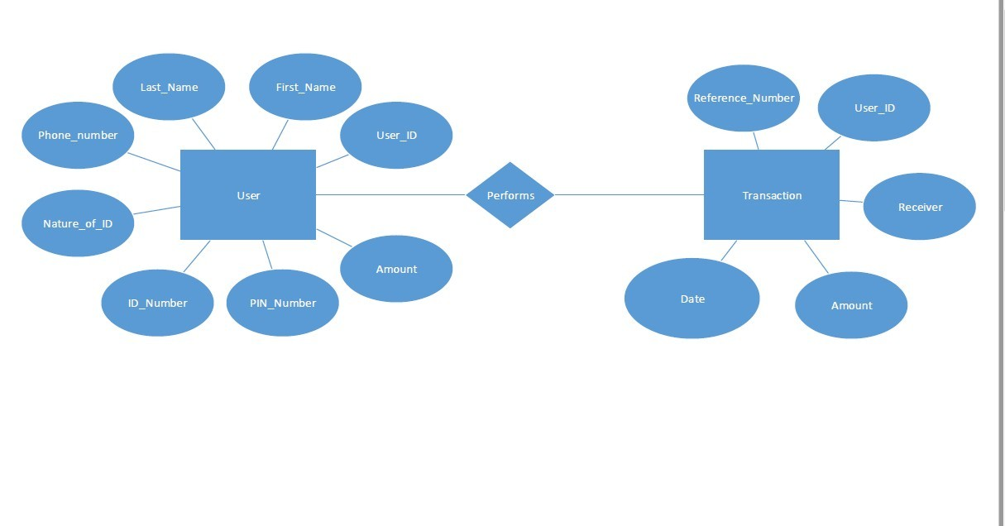

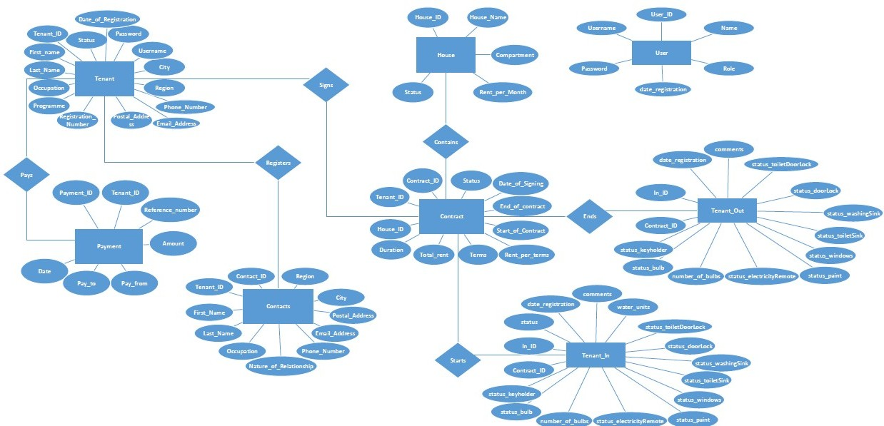 **PHYSICAL DATABASE DESIGN**.

This is translates the logical data model into a set of Structured Query Language (SQL) that define the database. The entities become the tables, attributes become the columns and relationships become foreign keys.

The figures below show the physical database designs for two databases involved in this system namely: tuma_pesa and rental_house databases.

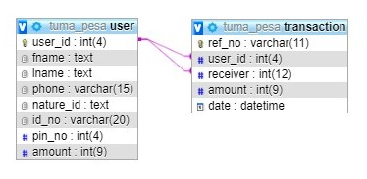

Figure: tuma_pesa database physical database design

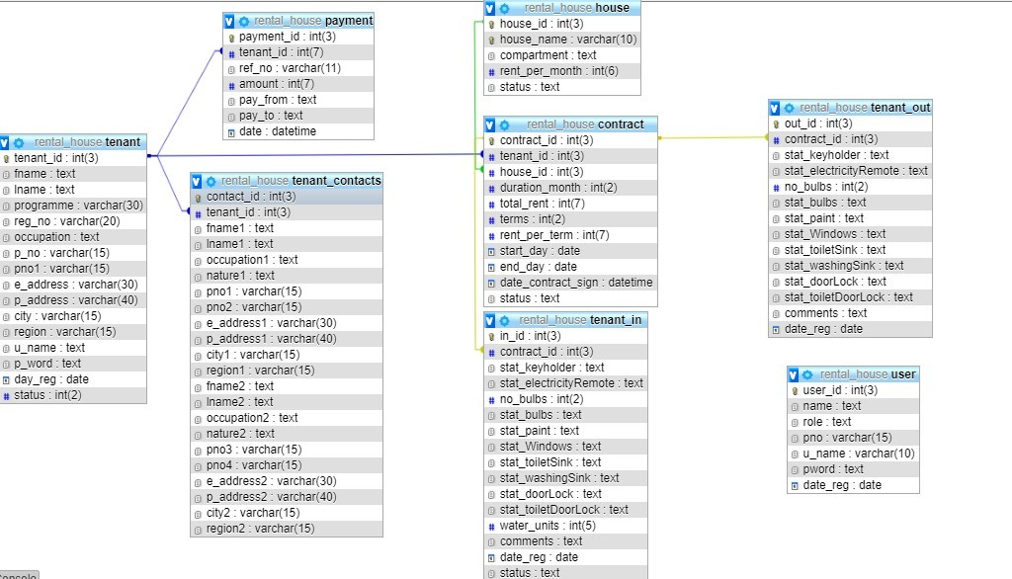

Figure: rental_house database physical database design.

**USE CASE DIAGRAM.**

Use case diagram is a UML diagram that representation of a user's interaction with the system that shows the relationship between the user and the different use cases in which the user is involved. It shows relationship between use cases, relationships and actors. These actors can either be internal or external agents or both.

In this system, there are three actors two are internal agents and one external agent. The internal agents are the **system administrator**and the **manager**while the external agent is the **tenant**.

The diagram below shows how the actors integrate with the system.

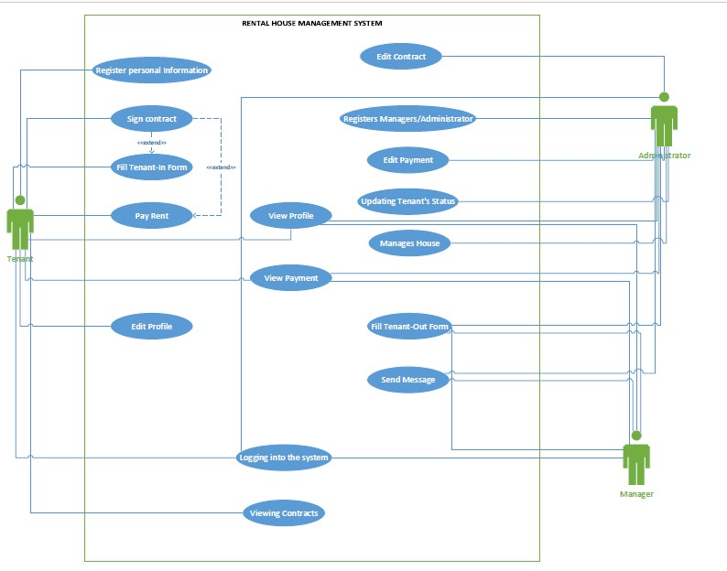

**ACTIVITY DIAGRAM**

An activity diagram is a type of UML (Unified Modeling Language) diagram that is commonly used in project management to illustrate the workflow or sequence of activities that are involved in a particular process or system. It provides a graphical representation of the steps or tasks involved in a process, along with the decision points, branching paths, and actions that are taken at each stage.

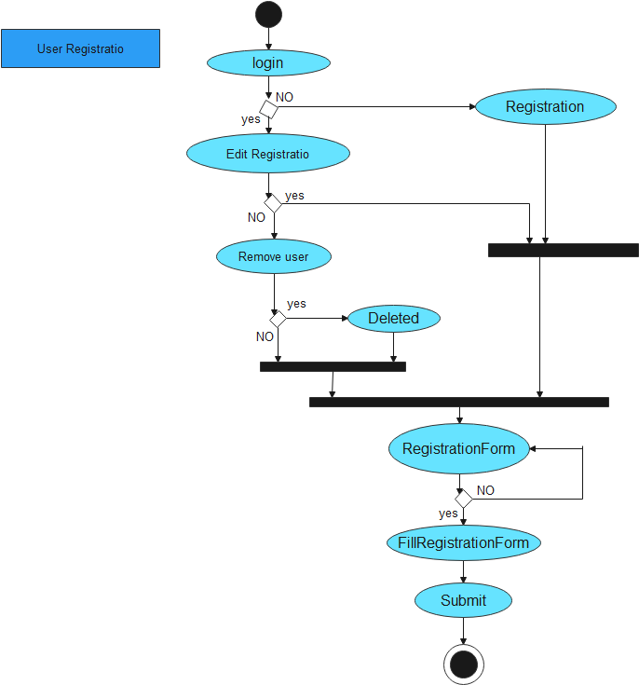

SEQUENCE DIAGRAM

A sequence diagram is a type of UML (Unified Modeling Language) diagram that shows the interactions and message exchanges between different objects or components in a system over time. It provides a graphical representation of the sequence of actions or events that occur during a particular use case or scenario.

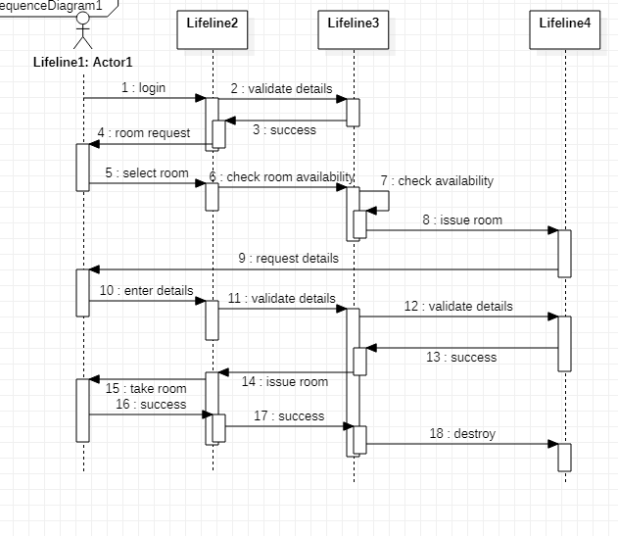

**SYSTEM IMPLEMENTATION**

This is the stage in which the theoretical design of the system is turned into working system. This chapter outlines the user interface of the system.

**USER INTERFACE.**

This refers to the process of making interface in software or computerized devices with a focus on looks or style. This system has been implemented using the following technologies: HTML, CSS, Bootstrap and JavaScript for frontend and PHP for backend. The system has a total of 45 PHP pages.

**INDEX PAGE.**

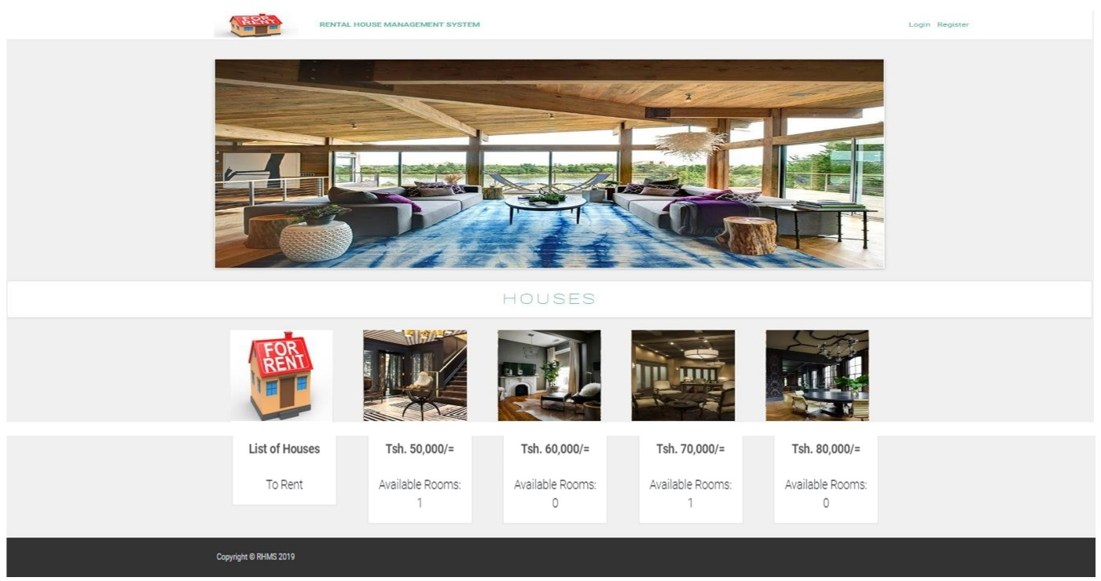

Figure :Index Page

This is the page that enables a landlord to advertise his houses to the public and enables a customer to view available rooms that one can rent.

It also provides an interface for the users of the system to login into the system and new customers to register into the system so as one can be able to rent a house. This is the first page users of the system and customers see before they can access the system.

**LOGIN PAGE.**

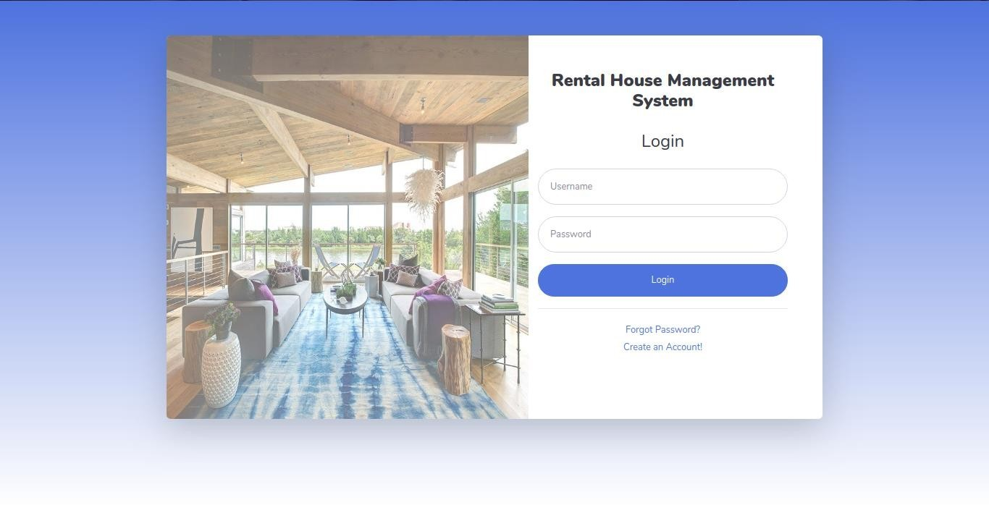

Figure: Login Page

This is the page that every user of the system enters their credentials before they can access the system. The tenants, system administrator and managers use this page to access their respective pages using their user names and passwords.

If any user wants to access other pages without logging into the system that is, without being in session, the system redirects the user to the login page.

**TENANT REGISTRATION PAGE**

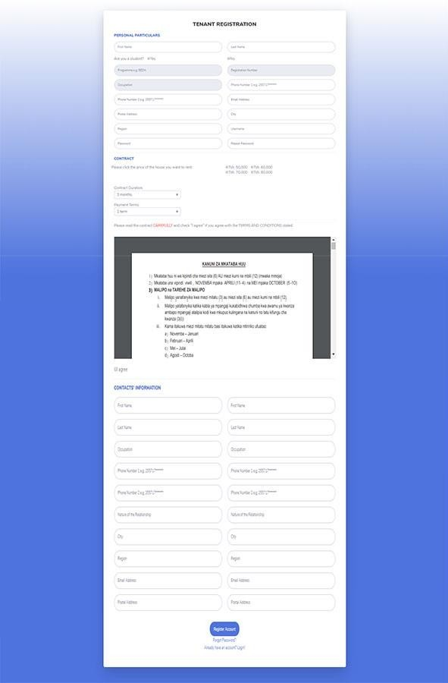

Figure: Tenant Registration Page.

This is the page that allows the new customer to create an account and sign a contract digitally by accepting the terms and conditions of the contract. Also allows the new customer to download and print the contract. The tenant has to fill all the required inputs else the system will inform the customer to fill the required fields else the information will be submitted to the database.

**.   RESET PASSWORD PAGE**

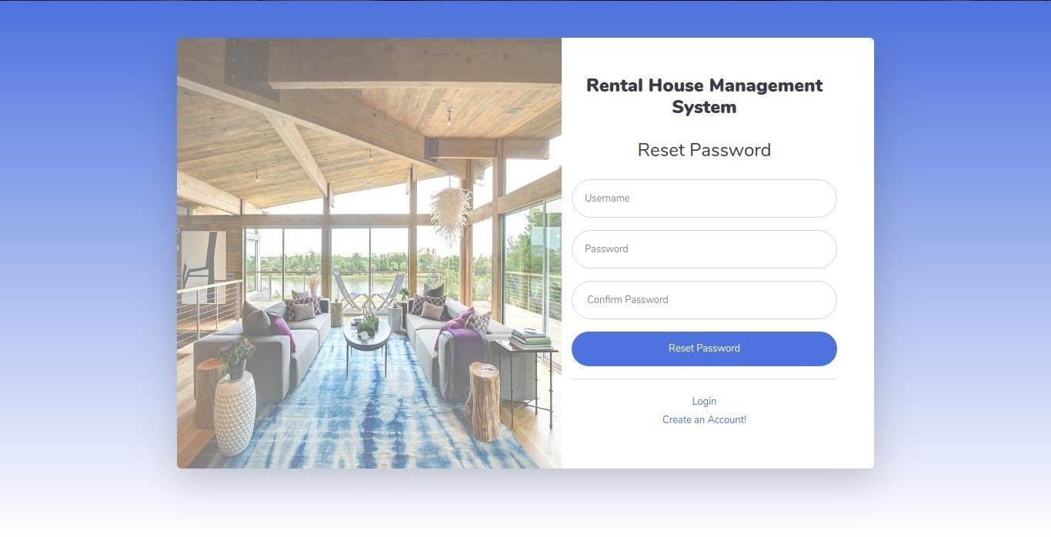

Figure :Reset Password Page

This is the page that allows the user of the system to reset password if one has forgot it using his existing username. The new password will then be updated in the database and hence the new password will be used upon login.

**CHANGE PASSWORD PAGE**

This is the page that allows the user of the system to change the password while accessing the system. This page is available to all the users of the system and a user can therefore change the password based on the tenant ID retrieved from the database unlike the reset password page.

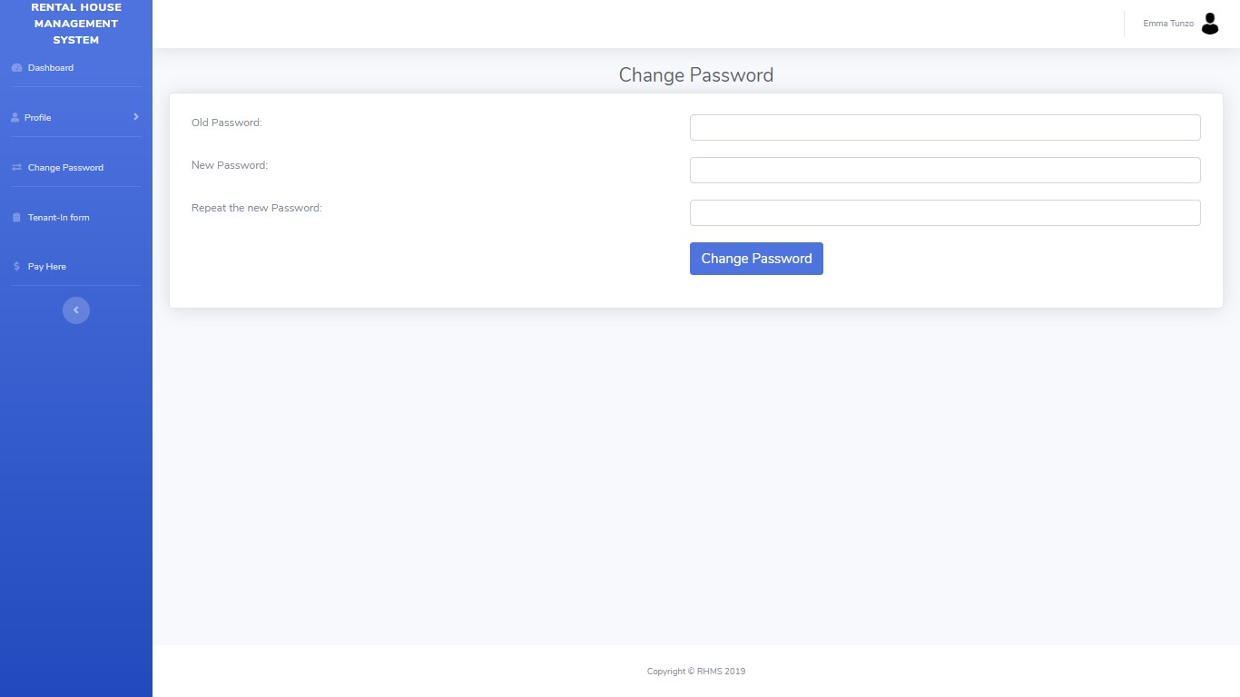

Figure: Change Password Page

**TENANT’S DASHBOARD.**

This is the page that a tenant sees after login. It contains tenant’s due dates and the room that a tenant is located. The tenant’s dashboard side navigation bar includes the following:

* Dashboard Menu
* Profile  Menu:  Personal,  Contact,  Contract  and  Payment  Information menus
* Tenant-In Menu
* Change Password Menu
* Pay Here Menu

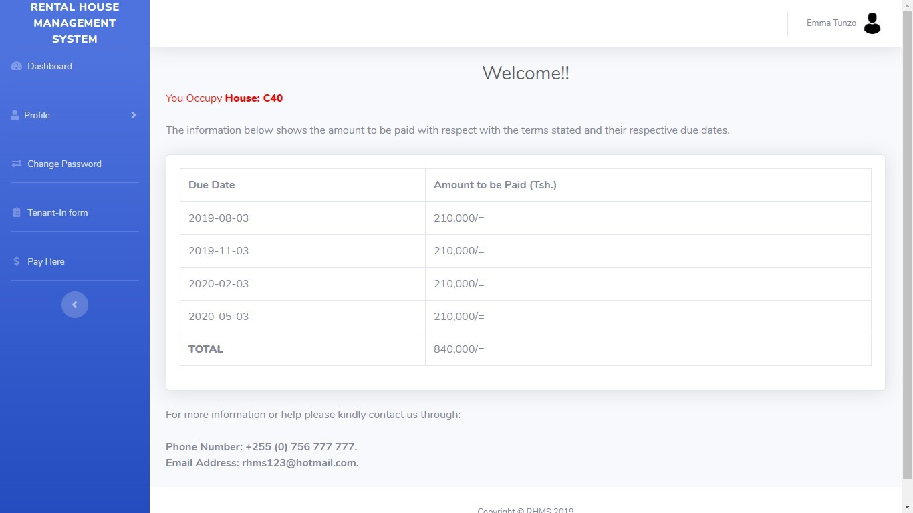

Figure: Tenant’s Dashboard

**TENANT-IN FORM**

This is the page that enables the tenant to fill basic information concerning the room that after signing the contract. This is filled by the tenant once as long as the contract is active else the system will tell the tenant that the form has already been filled.

All the fields are required to be filled by the tenant for assessment especially when he or she vacates the house.

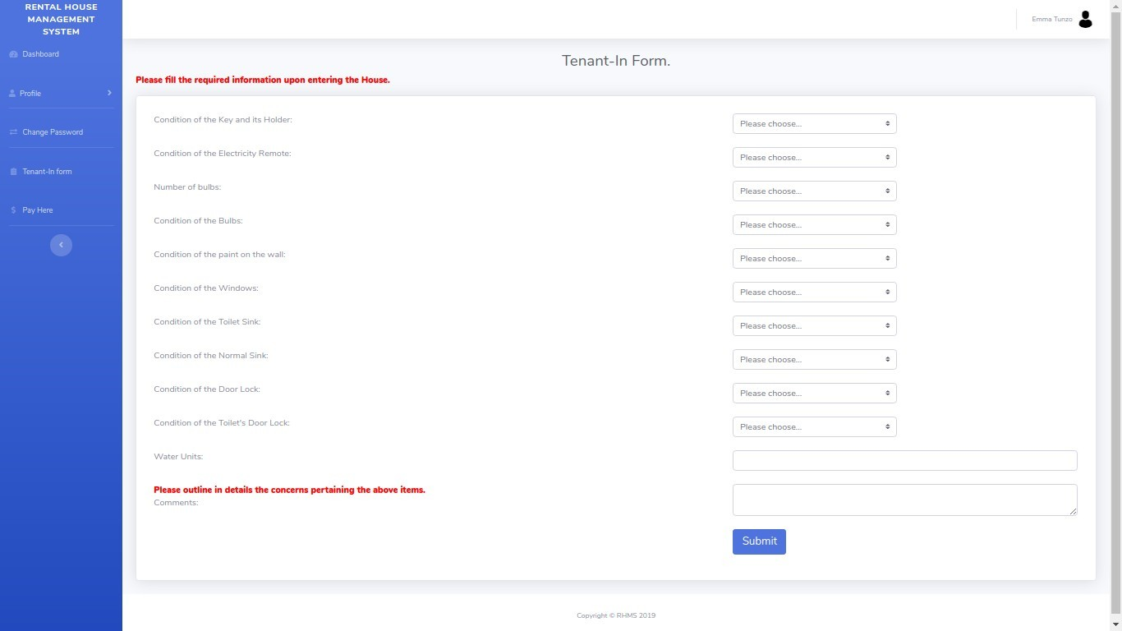

Figure: Tenant-In Page

.   **TUMAPESA PAYMENT PAGE**

This is the page that allows the tenant to perform transaction online via a simple database that simulates SIM transaction like Mpesa transaction. Therefore, if the tenants account in the tuma_pesa database is insufficient it will deny the transaction else it will allow the transaction and send the message to the tenant and landlord. This page requires the tenant to fill all the fields so as one can perform the transaction.

This page is available after the user registration or renewal of contact during initial payment and in the system when one wants to pay after the initial payment.

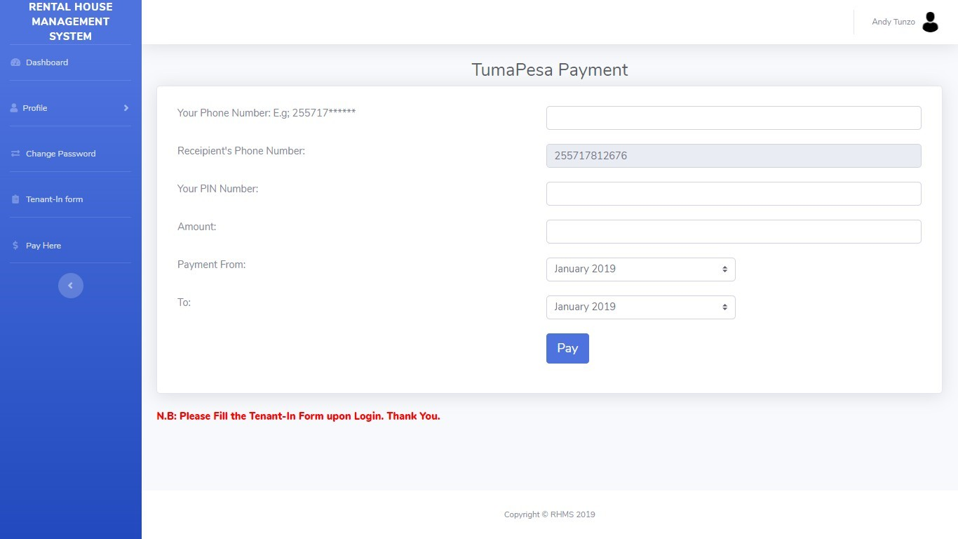

Figure: TumaPesa Payment Page

**TENANT PAYMENT DETAILS PAGE**

This is the page that retrieves the payment details from the database. It outlines the total amount of rent paid based on the active contract and calculate the arrears based on the active contract.

It also outlines the timeline that the rent has been paid for which enable the administrator and the manager to follow up on people who are behind their due dates.

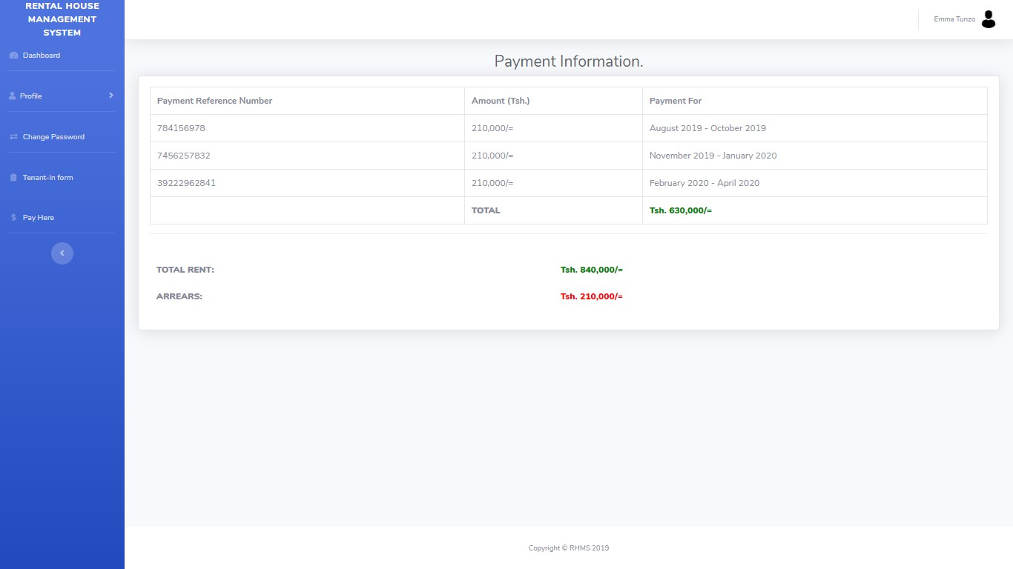

Figure: Payment Information Page

**. ADMINISTRATOR DASHBOARD**

This is the page that the system administrator sees after login. It contains the total number of tenants, active contracts and houses and total amount of income due to the payment. The administrator’s dashboard side navigation bar includes the following:

* Dashboard Menu
* House Menu: House Details, Add House, Change Cost of the House and Edit House Details.
* Contract Menu: Contract information, Edit contract Information (full), Edit contract Information(part).
* Tenant  Menu:  Tenant’s  Information,  Tenant’s  Contacts,  Tenant-In Information and Edit Tenant’s Information.
* Payment Menu: Payment Information and Edit Payment
* Tenant-Out Form Menu
* Messaging Menu
* Change Password Menu
* Register Menu

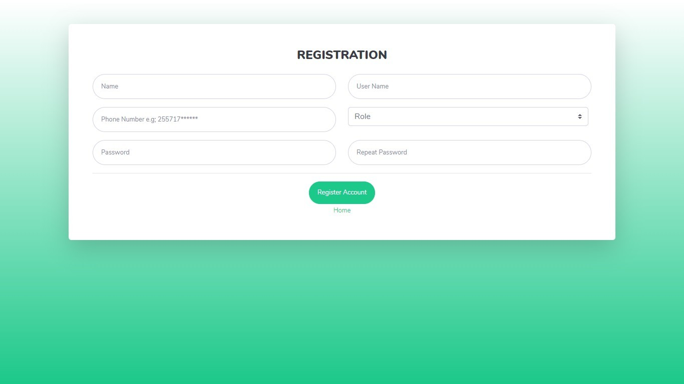

Figure: Administrator’s Dashboard Page.

**TENANT-OUT FORM**

This is the page that enables the manager or system administrator (landlord in this case) to fill basic information concerning the room that after the of the tenant’s contract. This is filled by the manager or system administrator once as long as the contract is inactive else the system will tell the manager or system administrator that the form has already been filled.

All the fields are required to be filled and this form is both present on the manager’s and administrator’s pages.

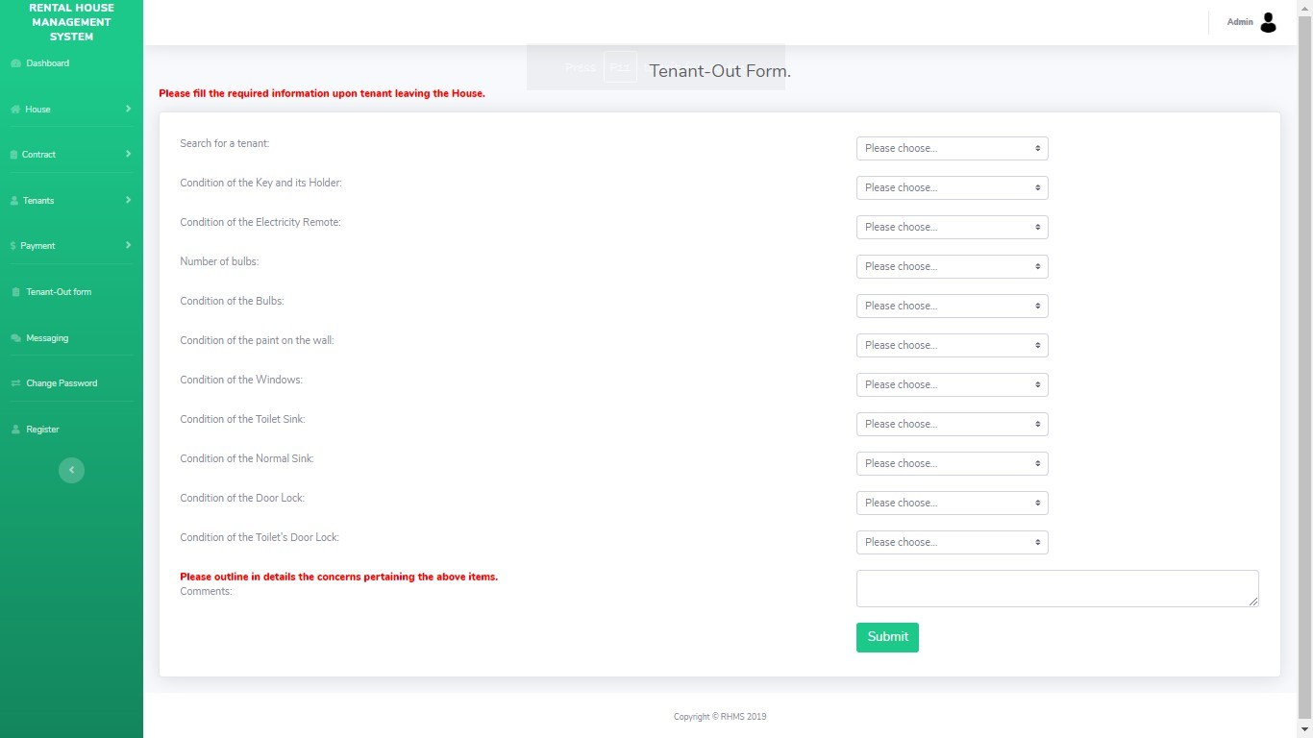

Figure: Tenant-Out Form

**TEXT MESSAGE PAGE**

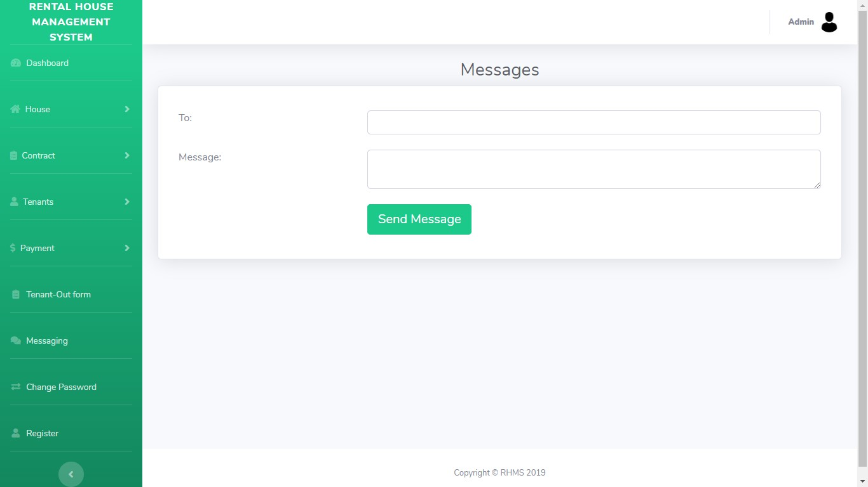

Figure: Text Message Page.

This is the page that helps the administrator and the manager to send message. The administrator can send text messages to all other users of the system while the manager can send text messages to the tenants. The API used to send message is known as **Nexmo SMS API**and its codes have been embedded to this system. This page is present to the administrator and manager pages respectively.

**ADMINISTRATOR’S REGISTRATION PAGE**



Figure: Administrator’s Registration Page

This is the page that allows the administrator to register new users of the system who are internal actors that is, the manager and the administrator. The administrator does not register tenants

**. ADD HOUSE PAGE**

This is the page that allows the administrator to register a new house. The house to be registered has to have the following attributes: its name, rent amount and specification if it has compartment or not.

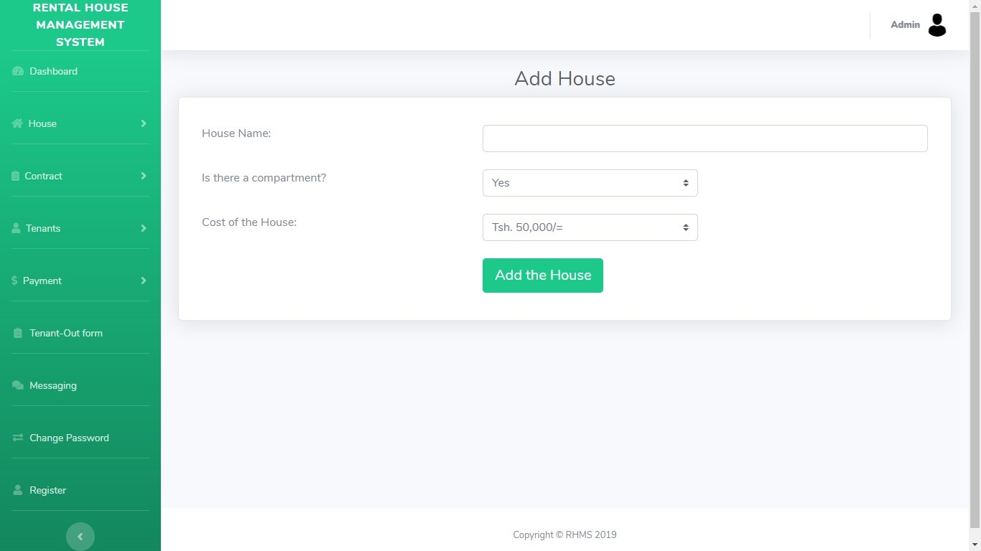

Figure: Add House Page

**MANAGER’S LIST OF PAYMENT PAGE**

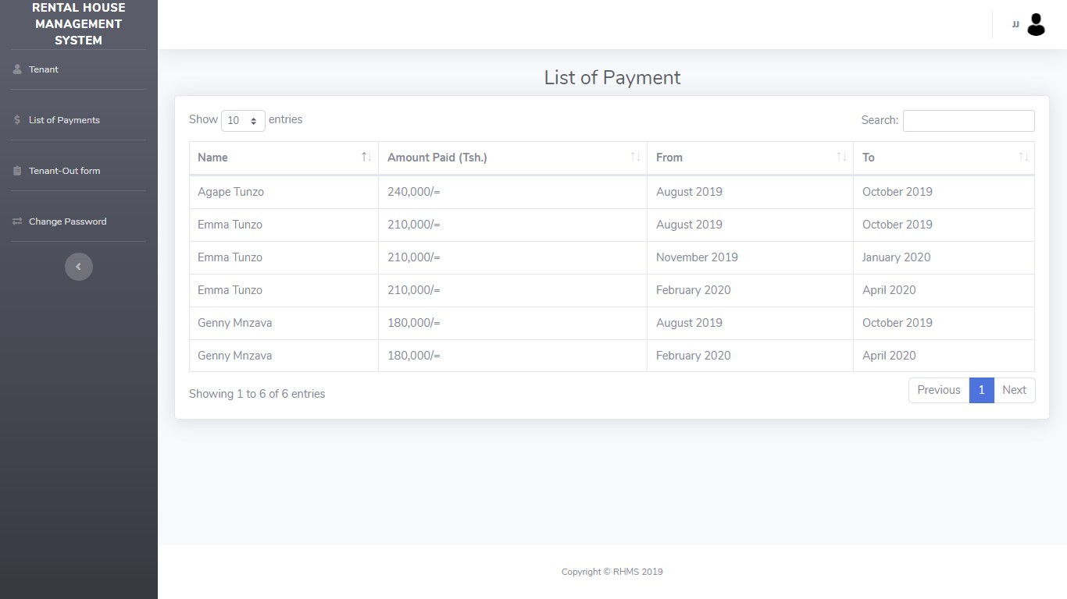

Figure: Manager’s List of Payment Page

This page allows the manager to make follow ups upon the tenant’s payment and determine when does the rent paid end. If the tenant is behind the due date the a manager can send a text message to the tenant.